

AMERICAN INTERNATIONAL UNIVERSITY–BANGLADESH (AIUB)

Faculty of Science and Technology

Dept. of Computer Science

COURSE: SOFTWARE ENGINEERING

Summer 2025-2026

Section: [M]

Group No: [H]

Software Requirement Specification [SRS] Document On

SyncSpace EDU: Academic Collaboration and Project Supervision Platform

Supervised By:

SOURAV AKIB SARKAR

Submitted By

Name |  | ID
1. | Md. Rajin Shahriar | 24-57561-2
2. | Purna Paul | 23-55146-3
3.
4.
5.

Table of Contents

1. INTRODUCTION 3
1.1 Background to the Problem 3
2. SCOPES & FEATURES 4
2.1 Scope 1: Fair Contribution Assessment 4
2.2 Scope 2: Centralized Project Collaboration 4
2.3 Scope 3: Instructor Monitoring and Progress Tracking 5
2.4 Scope 4: Milestone and Deadline Management 5
3. USE CASE DIAGRAM 6
4. USER STORY TABLE 8
5. REQUIREMENT TRACEABILITY MATRIX 9
5.1 Functional Requirements 9
5.2 Non-Functional Requirements 9

1. INTRODUCTION

Background to the Problem
University students frequently work on group projects as part of their academic curriculum. However, several challenges arise during project execution, including unequal contribution among group members, scattered communication across multiple platforms, and limited visibility for instructors regarding project progress and individual participation.
Currently, students rely on various disconnected tools such as Messenger, WhatsApp, Google Docs, Google Drive, and Email to collaborate on their coursework. This fragmented approach often leads to communication gaps, document version conflicts, missed deadlines, and difficulties in monitoring project activities. Instructors, in particular, are left with little objective evidence of who contributed what to a group submission, which makes fair assessment difficult and allows free-riding to go unnoticed until it is too late to intervene.
SyncSpace EDU addresses this gap by providing a single, web-based academic collaboration and project supervision platform designed specifically for university project groups. The platform brings communication, task management, document collaboration, file sharing, and progress tracking into one centralized environment. Automated contribution tracking gives instructors objective, measurable data on individual participation, while milestone and deadline management tools encourage students to work steadily throughout the semester rather than only before submission deadlines.
By situating the project within this context, SyncSpace EDU aims to improve transparency, accountability, collaboration efficiency, and overall project management within academic environments.
Target Users of the Solution
The primary users of SyncSpace EDU are members of the university community involved in group-based academic project work:
- Students — undergraduate students working in project groups who need a single place to communicate, manage tasks, edit shared documents, and track their own contribution.
- Project Leaders — students appointed to coordinate a project group, who need to assign tasks, set milestones, and monitor overall team progress.
- Instructors / Course Supervisors — faculty members who need visibility into group activity, objective contribution data, and progress reports in order to guide and fairly evaluate student teams.

SCOPES & FEATURES

Scope 1: Fair Contribution Assessment
In group projects, some students contribute significantly while others contribute very little. Instructors often lack objective data to evaluate individual participation. The system will provide measurable contribution statistics, helping instructors assess students fairly.
Features
- Contribution Tracking System
- Activity Monitoring
- Task Completion Analytics
- Document Edit Tracking
- File Upload Tracking
- Chat Participation Analysis
- Contribution Leaderboard
- Individual Contribution Score

Scope 2: Centralized Project Collaboration
Students use multiple disconnected platforms for communication, documentation, task management, and file sharing. Students can perform all project-related activities from a single platform, reducing confusion and improving productivity.
Features
- Team Chat
- Shared Documents
- Task Management Board
- File Repository
- Notifications
- Project Timeline
- Team Workspace

Scope 3: Instructor Monitoring and Progress Tracking
Instructors often cannot determine project status until the final submission date. Instructors can monitor project progress continuously and provide timely guidance.
Features
- Faculty Dashboard
- Project Progress Monitoring
- Group Activity Reports
- Deadline Tracking
- Risk Detection
- Contribution Analytics
- Milestone Tracking
- Project Health Score

Scope 4: Milestone and Deadline Management
Many student groups delay work until shortly before project submission. Students will be encouraged to follow structured project schedules and complete work on time.
Features
- Milestone Creation
- Deadline Management
- Automated Reminders
- Progress Visualization
- Gantt-style Timeline
- Completion Tracking

USE CASE DIAGRAM
The system consists of three primary actors: Student, Project Leader, and Instructor. All three roles authenticate through the same shared Register / Login use case, since SyncSpace EDU uses a single unified sign-in flow and assigns role-based access after authentication rather than separate login paths per role. Students collaborate within project groups by managing tasks, editing documents, communicating through chat, and sharing files. Project Leaders supervise team activities by managing group membership, assigning tasks, and creating project milestones. Instructors monitor overall project progress, evaluate individual contributions, and generate reports for assessment purposes.

Actors and Responsibilities
Student
- Register / Login (shared across all roles)
- Join Project Group
- Create & Complete Tasks
- Edit Shared Documents
- Upload Files
- Send Messages (Team Chat)
- View Contribution Score
- Receive Deadline Reminders
Project Leader
- Register / Login (shared across all roles)
- Manage Group Members
- Assign Tasks
- Create Milestones
- Monitor Team Progress
Instructor
- Register / Login (shared across all roles)
- Monitor Group Progress
- View Contribution Analytics
- Generate Evaluation Reports
- Receive Risk Alerts for At-Risk Groups

Use Case Diagram

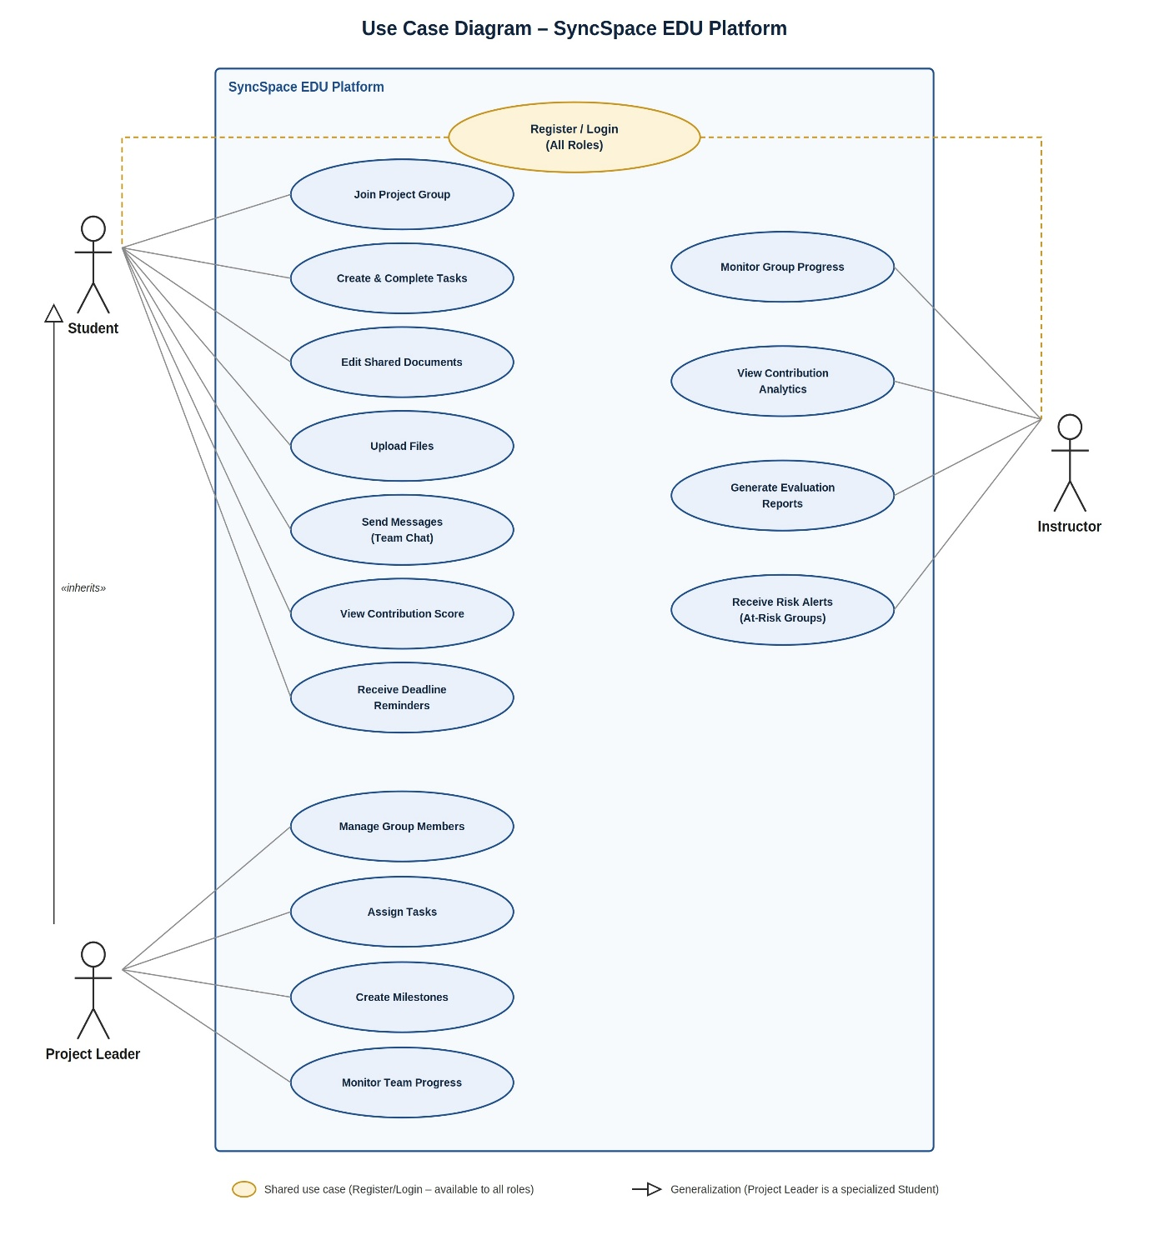

Figure 1: Use Case Diagram of the SyncSpace EDU Platform

USER STORY TABLE
ID | User | User Story | Priority | Developer's Justification
US-01 | Student | As a student, I want to join a project group so that I can collaborate with teammates. | High | A join-by-invite-code flow creates a membership record linking the student to the workspace, with the role defaulted to Member.
US-02 | Student | As a student, I want to edit shared documents so that team members can work together. | High | Documents use a real-time collaborative editor with autosave, so members can edit concurrently and see changes live.
US-03 | Student | As a student, I want to upload files so that project resources remain accessible. | Medium | Uploaded files are stored in cloud object storage; file metadata (owner, size, timestamp) is kept in the database and a shareable link is generated.
US-04 | Student | As a student, I want to communicate through team chat so that collaboration becomes easier. | High | A per-workspace chat channel delivers messages in real time, with full message history persisted for the group.
US-05 | Student | As a student, I want to track my contribution score so that I know my participation level. | High | A scoring job aggregates task completions, edits, uploads, and chat activity into a weighted contribution score that refreshes periodically.
US-06 | Project Leader | As a project leader, I want to assign tasks so that responsibilities are distributed among members. | High | The task creation form lets the leader assign an owner from the member list, updating the task record and notifying the assignee.
US-07 | Project Leader | As a project leader, I want to create milestones so that project progress can be monitored. | Medium | Milestones store a target date and linked tasks; progress is derived from the completion of those tasks.
US-08 | Instructor | As an instructor, I want to monitor project progress so that I can identify struggling groups. | High | The instructor dashboard aggregates per-workspace metrics (task completion, activity trend, last-active date) in real time across all groups.
US-09 | Instructor | As an instructor, I want to view contribution analytics so that grading becomes fair. | High | The analytics view visualizes each member's contribution score and activity breakdown using the same scoring engine as the student view.
US-10 | Instructor | As an instructor, I want to generate project reports so that student performance can be evaluated. | Medium | A report-generation endpoint exports group and individual performance data as PDF/CSV for grading records.
US-11 | Project Leader | As a project leader, I want to manage group membership so that I can add or remove teammates as needed. | Medium | A membership-management panel lets the leader invite members via invite code or remove inactive ones, updating the membership table.
US-12 | Project Leader | As a project leader, I want to monitor my team's task and milestone progress so that I can keep the project on track. | High | A leader-facing progress view reuses the instructor analytics engine, scoped to the leader's group, showing task and milestone completion.
US-13 | Student | As a student, I want to receive deadline reminders so that I never miss a milestone. | High | Reminder records (7, 3, and 1 day before the due date, plus an overdue alert) are generated when a milestone is created and sent to the student on schedule.
US-14 | Instructor | As an instructor, I want to be alerted to at-risk and inactive groups so that I can intervene early. | High | A risk-detection engine scores groups on inactive members, low contribution, and delayed milestones, surfacing risk alerts and a health score on the instructor dashboard.

REQUIREMENT TRACEABILITY MATRIX

Functional Requirements
ID | Requirement
FR-01 | Users shall be able to register and log in.
FR-02 | Students shall be able to join project groups.
FR-03 | Students shall be able to create, update, and complete tasks.
FR-04 | Students shall be able to edit collaborative documents.
FR-05 | Students shall be able to upload and download files.
FR-06 | Students shall be able to communicate through real-time chat.
FR-07 | The system shall calculate contribution scores automatically.
FR-08 | Project leaders shall be able to assign tasks.
FR-09 | Project leaders shall be able to create milestones.
FR-10 | Instructors shall be able to monitor project progress.
FR-11 | Instructors shall be able to view contribution analytics.
FR-12 | The system shall generate project reports.
FR-13 | The system shall generate automated deadline-reminder records (7, 3, and 1 day before the due date, plus an overdue alert) for each milestone and notify affected students.
FR-14 | The system shall detect inactive members and project risks.
FR-15 | Project leaders shall be able to manage group membership (add or remove members).
FR-16 | Project leaders shall be able to monitor their own team's task and milestone progress.
FR-17 | The system shall display a contribution leaderboard for each project group.
FR-18 | The system shall compute and display a project health score for each project group.
FR-19 | The system shall provide a Gantt-style visual timeline of milestones for each project group.
FR-20 | The system shall provide in-app notifications for task assignments, milestone reminders, and risk alerts.

Non-Functional Requirements
ID | Requirement
NFR-01 | The system shall provide a responsive user interface for desktop and mobile devices.
NFR-02 | The system shall support at least 100 concurrent users with an average response time of under 500 ms under normal load.
NFR-03 | User passwords shall be securely encrypted.
NFR-04 | The system shall maintain 99% uptime, measured monthly and excluding scheduled maintenance windows.
NFR-05 | Real-time chat and collaborative editing messages shall be delivered within 500 ms (95th percentile) over a stable connection.
NFR-06 | The system shall model the Student, Project Leader, and Instructor roles and scope data visibility to the user's role and group membership.
NFR-07 | The system shall perform an automated database backup at least once daily, with point-in-time recovery available within 24 hours.
NFR-08 | The system shall ensure data integrity and consistency.
NFR-09 | The platform shall scale horizontally to support at least 1,000 registered users without requiring architectural changes.
NFR-10 | A new user shall be able to complete core onboarding (join a project group, create a task, and send a chat message) within 10 minutes without external assistance.

